Supplementary Material 4D. Percentage of treating with endovascular thrombectomy (EVT) by Hospital Service Areas (HSAs)
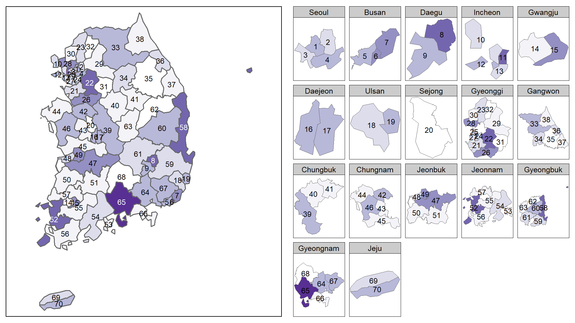
Values are presented as colors according to the category of measurements
NA, not available area
Map was provided with the entire map separated by HSA boundaries and separated map by SIDO, which is administrate unit of provincial-level in Korea, to solve the problem of being invisible due to the area size of region.
Hospital service areas (HSAs) was marked as HSA number instead of HSA name. HSA number corresponding to the HSA code can be found in Supplementary Material 1.

