Supplemental Materials

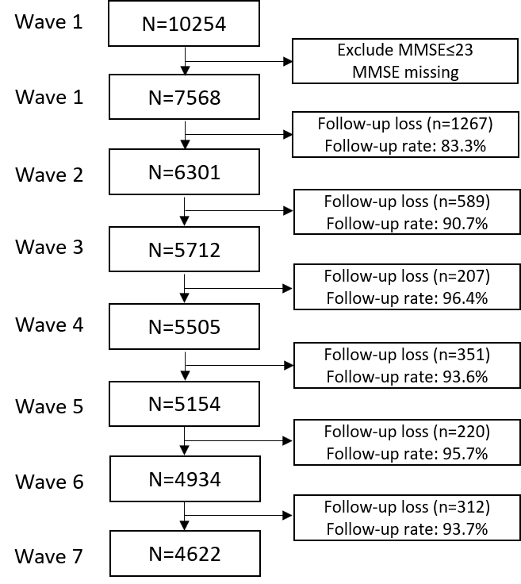
Supplemental Material 1. Flow diagram showing the process of selecting study percipients

