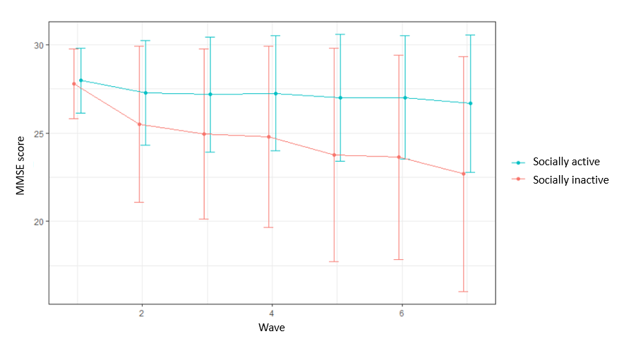
Supplemental Material 2. MMSE score in individuals who participate in social activities and those who do not participate in any social activities.

