Supplemental materials

Study participants
The flow chart for the study participants was presented in Figure S1. Among the 2118 adults in the cohort, the Korean Research Project on the Integrated Exposure Assessment of Hazardous Substances for Food Safety (KRIEFS) cohort, 1604 participants were excluded due to loss of follow-up and 514 participants were followed-up. 506 participants (1016 observations) were included in the analysis, excluding 6 participants whose blood mercury or liver enzymes were not measured in the baseline survey (2010-2011) or follow-up survey (2014-2015).

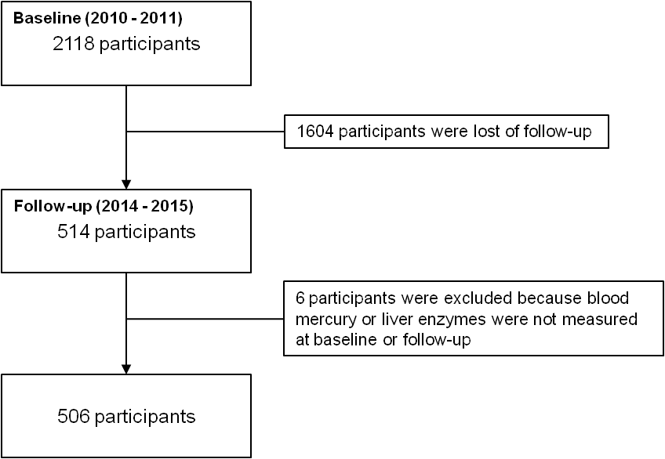
Supplemental Figure 1. Flow chart of the study population.

Change of liver enzymes
The distribution of relative change (%) in blood mercury and liver enzymes from baseline (2010-2011) to follow-up (2014-2015) in each individuals is shown in Table S1. The relative change was defined as (value in follow-up survey ÷ value in baseline survey) × 100. Blood mercury decreased by 14.4% from baseline to follow-up on average, AST decreased by 0.1%, ALT increased by 27.7% and GGT increased by 15.3% on average.

Supplemental Table 1. Changes of blood mercury and liver enzymes from baseline (2010-2011) to follow-up (2014-2015)
Blood mercury or Liver enzymes | Mean (SD) | Min | 1st Q | Median | 3rd Q | Max
Δ-Hg (%) | -14.4 (59.0) | -92.4 | -47.0 | -22.6 | 6.2 | 895.8
Δ-AST (%) | -0.1 (66.6) | -86.8 | -36.5 | -16.7 | 15.0 | 676.5
Δ-ALT (%) | 27.7 (68.9) | -80.7 | -12.9 | 21.1 | 50.0 | 736.4
Δ-GGT (%) | 15.3 (79.6) | -87.6 | -18.2 | 0.0 | 25.1 | 1014.0
Δ-:= {(value at follow-up ÷ value at baseline) -1} × 100
Hg, mercury; AST, aspartate aminotransferases; ALT, alanine transaminase; GGT, gamma-glutamyltransferase; SD, standard deviation; Min, minimum; 1st Q, 1st quartile, 3rd Q, 3rd quartile, Max, maximum.

The associations between the blood mercury in the baseline survey or the relative changes in blood mercury levels defined as above and the relative changes in liver enzyme was assessed by multiple linear regression analysis. The relative changes in liver enzymes were not statistically significant changed according to blood mercury in the baseline survey or relative changes in blood mercury levels.

Supplemental Table 2. Association between blood mercury and change of liver enzymes from baseline (2010-2011) to follow-up (2014-2015)
 |  | Crude |  | Model 1 |  | Model 2
Response | Predictor | β (SE) | p-value | β (SE) | p-value | β (SE) | p-value
Δ-AST (%) | Baseline Hg (μg/L) | 0.22 (0.67) | 0.74 | 0.33 (0.69) | 0.63 | -0.21 (0.83) | 0.80
 | Δ-Hg (%) | - | - | 0.04 (0.05) | 0.48 | 0.02 (0.06) | 0.70
Δ-ALT (%) | Baseline Hg (μg/L) | -0.40 (0.63) | 0.52 | -0.49 (0.64) | 0.45 | 0.43 (0.75) | 0.57
 | Δ-Hg (%) | - | - | -0.03 (0.05) | 0.55 | -0.04 (0.05) | 0.50
Δ-GGT (%) | Baseline Hg (μg/L) | 1.18 (0.82) | 0.15 | 1.22 (0.84) | 0.15 | 1.48 (1.01) | 0.14
 | Δ-Hg (%) | - | - | 0.01 (0.06) | 0.84 | 0.01 (0.07) | 0.93
Δ-:= {(value at follow-up ÷ value at baseline) -1} × 100.
Hg, mercury; AST, aspartate aminotransferases; ALT, alanine transaminase; GGT, gamma-glutamyltransferase; SE, standard error.
Crude model included blood mercury at baseline (μg/L) adjusted for each liver enzyme levels at baseline; Model 1 included blood mercury at baseline (μg/L) and change of blood mercury (%) adjusted for each liver enzyme levels at baseline; Model 2 was adjusted for each liver enzyme levels at baseline, gender, change of age, change of income, change of smoking status, change of alcohol consumption frequency levels and past medical history of hypertension, diabetes mellitus, tuberculosis, hepatitis B. Change of age:= absolute difference of age (years) from baseline to follow-up periods. Change of income:= absolute difference of level of income variable treated as numerical variable (Assuming that the difference between each next level in the order is 1) from baseline to follow-up periods. Change of alcohol consumption frequency:= absolute difference of level of alcohol consumption frequency variable treated as numerical variable (Assuming that the difference between each next level in the order is 1) from baseline to follow-up periods.

Frequency and amount of alcohol consumption
The association between frequency and amount of alcohol consumption measured by the questionnaires at the baseline (2010-2011) and the follow-up survey (2014-2015) is shown in Table S3. The higher frequency of alcohol consumption, the higher amount of alcohol consumption, and the frequency and amount of alcohol consumption were highly associated (p <0.001).

Supplemental Table 3. Association between frequency and amount of alcohol consumption
Survey wave | Amount of alcohol consumption | Frequency of alcohol consumption
 |  | None | <1/mo | 1/mo | 2-4 times/mo | 2-3 times/wk | 4+ times/wk | p-value
Baseline | 1-2 cups a drink | 1 (50.0) | 59 (79.7) | 35 (51.5) | 22 (18.8) | 6 (8.1) | 8 (17.0)
 | 3-4 cups a drink | 1 (50.0) | 8 (10.8) | 22 (32.4) | 32 (27.4) | 18 (24.3) | 11 (23.4)
 | 5-6 cups a drink | 0 (0.0) | 5 (6.8) | 8 (11.8) | 30 (25.6) | 15 (20.3) | 6 (12.8)
 | 7-9 cups a drink | 0 (0.0) | 1 (1.4) | 0 (0.0) | 22 (18.8) | 18 (24.3) | 5 (10.6)
 | 10 cups or more a drink | 0 (0.0) | 1 (1.4) | 3 (4.4) | 11 (9.4) | 17 (23.0) | 17 (36.2) | <0.001
Follow-up | 1-2 cups a drink | 6 (60.0) | 48 (60.8) | 22 (44.0) | 34 (26.4) | 13 (16.5) | 5 (15.2)
 | 3-4 cups a drink | 0 (0.0) | 19 (24.1) | 18 (36.0) | 49 (38.0) | 14 (17.7) | 4 (12.1)
 | 5-6 cups a drink | 1 (10.0) | 8 (10.1) | 4 (8.0) | 19 (14.7) | 18 (22.8) | 6 (18.2)
 | 7-9 cups a drink | 0 (0.0) | 2 (2.5) | 4 (8.0) | 16 (12.4) | 10 (12.7) | 6 (18.2)
 | 10 cups or more a drink | 3 (30.0) | 2 (2.5) | 2 (4.0) | 11 (8.5) | 24 (30.4) | 12 (36.4) | <0.001
Values are presented as number (%).
p-value were calculated using chi-square and fisher’s exact test, and both were calculated as <0.001.

From the Table 4 of main text assessed the associations between the blood mercury and the liver enzymes changed over times by generalized estimating equation(GEE), the sensitivity analysis was performed by replacing the alcohol consumption frequency with the alcohol consumption amount (Table S4). The association between blood mercury and GGT in men was observed in model 3. In women, the associations between blood mercury and GGT were observed in model 2 and 3, and the association between blood mercury and AST was observed in model 3. In women, statistically significant association between blood mercury and GGT was observed in both low- and high-amount of alcohol consumption groups, but in men, the association was observed only in group with high-amount of alcohol consumption.

Supplemental Table 4. Generalized Estimating Equations (GEE) model on association between blood mercury levels and liver enzymes from baseline (2010-2011) to follow-up (2014-2015) stratified by gender
 |  | AST |  | ALT |  | GGT
 |  | % change (95% CI)¹ | p for interaction² | % change (95% CI)¹ | p for interaction² | % change (95% CI)¹ | p for interaction²
Men | Model 2 | 2.0 (-3.0, 7.2) |  | 0.2 (-5.3, 6.1) |  | 9.8 (-0.9, 21.7)†
 | Model 3 | 1.7 (-3.6, 7.4) |  | 1.0 (-4.2, 6.4) |  | 13.6 (3.9, 24.2)*
 | Alcohol consumption amount³
 | lesser than 7 cups a drink | 1.4 (-4.9, 8.0) |  | 1.3 (-4.7, 7.6) |  | 8.0 (-2.5, 19.7)
 | 7 cups or more a drink | 0.6 (-7.9, 9.9) | 0.41 | -1.2 (-10.0, 8.4) | 0.63 | 20.2 (4.6, 38.1)* | 0.06
Women | Model 2 | 4.8 (-0.7, 10.7) |  | 0.9 (-4.6, 6.8) |  | 9.8 (1.1, 19.2)*
 | Model 3 | 6.3 (0.4, 12.5)* |  | 2.3 (-3.3, 8.1) |  | 12.4 (4.0, 21.5)*
 | Alcohol consumption amount³
 | lesser than 7 cups a drink | 4.4 (-1.4, 10.4) |  | 2.1 (-3.3, 7.8) |  | 11.4 (3.1, 20.4)*
 | 7 cups or more a drink | 11.2 (-8.3, 34.9) | 0.49 | -1.8 (-11.7, 9.3) | 0.31 | 28.0 (5.6, 55.3)* | 0.89
p for interaction between gender⁴ |  |  | 0.04 |  | 0.92 |  | 0.26
Models 2 and 3 correspond to the substitutions of model 2 and 3 in Table 4 for alcohol consumption amount instead of frequency. model 2 included age, income, period, fish consumption, smoking and alcohol consumption amount; model 3 additionally included past medical history of hypertension, diabetes mellitus, tuberculosis, hepatitis B in the model 2. In each model, age, income, period, fish consumption, smoking and alcohol consumption amount as well as blood mercury and liver enzymes are considered time-varying covariates.
Hg, mercury; CI, confidence interval; AST, aspartate aminotransferases; ALT, alanine transaminase; GGT, gamma-glutamyltransferase.
¹% change of liver enzyme per doubling of blood mercury level.
²Interaction between blood mercury level and alcohol consumption amount in association with liver enzymes was evaluated by interaction term in the corresponding model.
³After stratification by alcohol consumption amount, the same covariates as model 3 were included.
⁴Interaction between blood mercury level and gender in association with liver enzymes was evaluated by interaction term in the corresponding model 3.
†p<0.1, *p<0.05.

