Supplemental Material 1. Figures for Timeline of COVID-19 and the number of cumulative confirmed cases in the world.

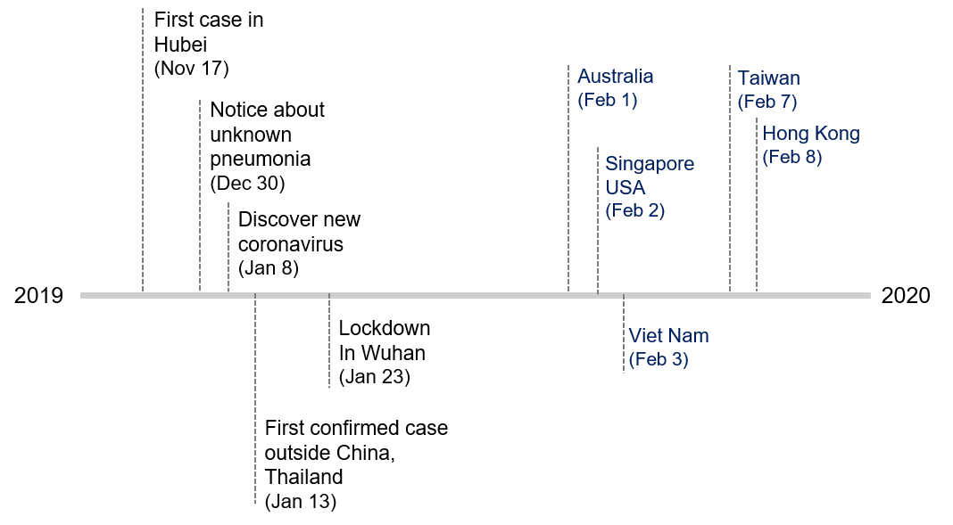
Figure S1. Timeline of COVID-19 as of February 29

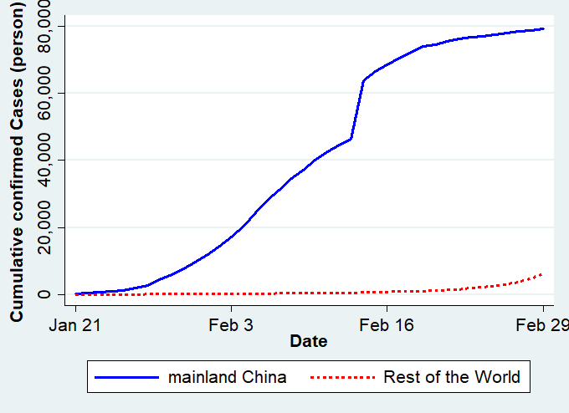
Figure S2. Cumulative Confirmed Cases: mainland China vs. the rest of the world (55) : On February 14, the Chinese government included clinically diagnosed cases, which caused a big jump. Mainland China does not include Hong Kong, Macao, or Taiwan.

