Supplemental Material 3. The analysis of placebo tests and the results of the synthetic control methods in detail by country.

a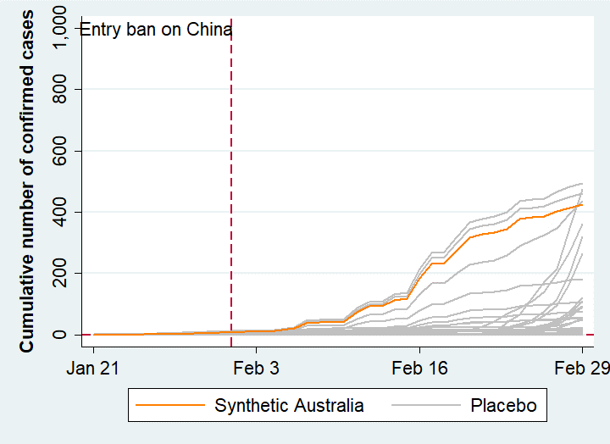 | b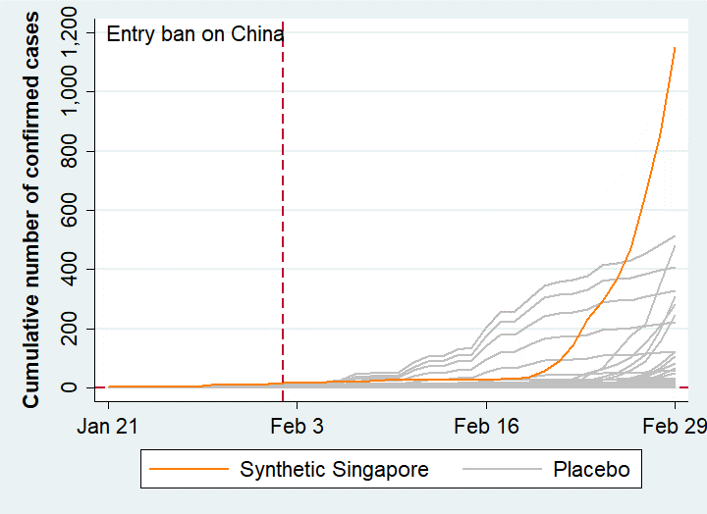
c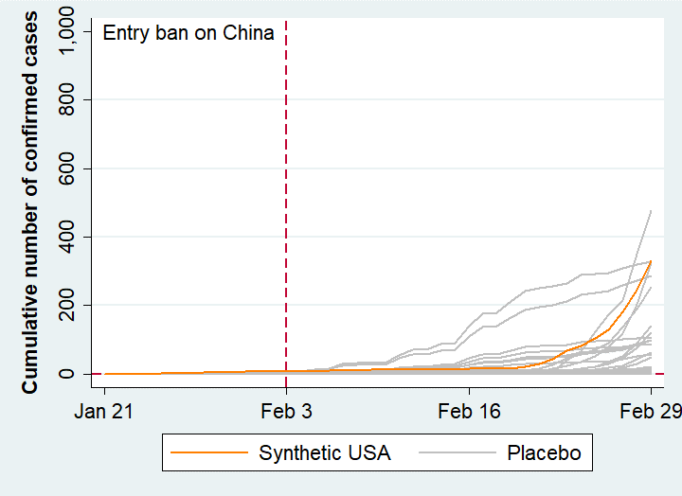 | d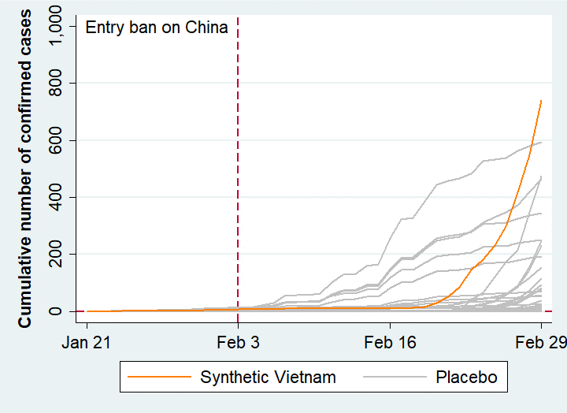
e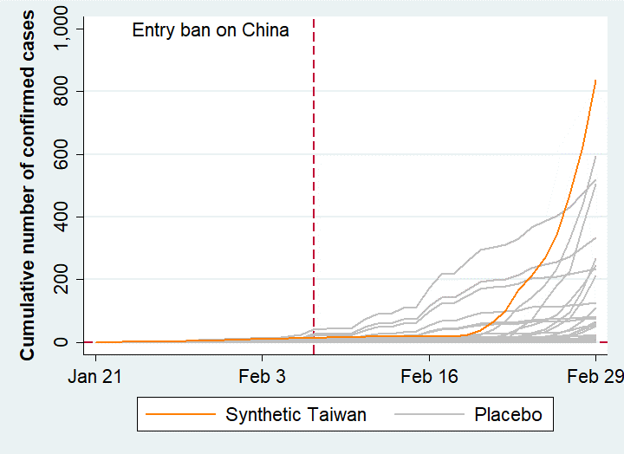 | f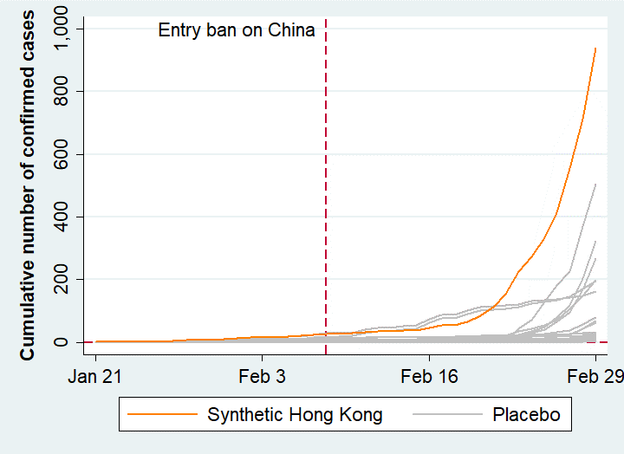
Figure S1. Cumulative number of confirmed cases in synthetic countries and placebo cases (discard countries with pre-intervention MSPE three times higher than treated countries’)
Table S1. Factors considered for the spread of the COVID-19, Australia

 | Australia
Variables | Real | Synthetic
Demographic factors
Log Population (total) | 17.03 | 17.03
Aged population (% of total population) | 15.66 | 18.51
Economic factors
Log GNI per capita(US$) | 10.88 | 10.86
Health condition and Health care environments
Life expectancy | 82.50 | 82.23
Health expenditure(% of GDP) | 9.25 | 9.27
Physicians(per 1,000 people) | 3.59 | 3.13
Chinese visitors
Log Chinese arrivals | 14.17 | 14.37

Table S2. Country weights in the synthetic Australia

Country | Weight
Japan | 0.448
Norway | 0.348
United Arab Emirates | 0.204

Table S3. Effects of entry ban on the COVOD-19 epidemic. Cumulative number of confirmed cases of real Australia (with entry ban), synthetic Australia (without entry ban), and avoidable infected cases. Avoidable infected cases are calculated by subtracting real Australia (without entry ban) from Synthetic (with entry ban) cases.

DATE | Real  Australia | Synthetic Australia | Avoidable  infected  cases | DATE | Real  Australia | Synthetic Australia | Avoidable  infected  cases
2020-01-21 | 0 | 0.448 | 0.448 | 2020-02-10 | 15 | 44.436 | 29.436
2020-01-22 | 0 | 0.448 | 0.448 | 2020-02-11 | 15 | 73.76 | 58.76
2020-01-23 | 0 | 0.448 | 0.448 | 2020-02-12 | 15 | 92.576 | 77.576
2020-01-24 | 0 | 0.448 | 0.448 | 2020-02-13 | 15 | 92.576 | 77.576
2020-01-25 | 3 | 1.344 | -1.656 | 2020-02-14 | 15 | 114.08 | 99.08
2020-01-26 | 4 | 1.344 | -2.656 | 2020-02-15 | 15 | 117.664 | 102.664
2020-01-27 | 4 | 1.792 | -2.208 | 2020-02-16 | 15 | 184.416 | 169.416
2020-01-28 | 5 | 2.688 | -2.312 | 2020-02-17 | 15 | 231.66 | 216.66
2020-01-29 | 7 | 3.952 | -3.048 | 2020-02-18 | 15 | 234.348 | 219.348
2020-01-30 | 7 | 5.744 | -1.256 | 2020-02-19 | 15 | 277.356 | 262.356
2020-01-31 | 9 | 7.088 | -1.912 | 2020-02-20 | 15 | 318.124 | 303.124
2020-02-01 | 12 | 8.432 | -3.568 | 2020-02-21 | 17 | 327.532 | 310.532
2020-02-02 | 12 | 9.98 | -2.02 | 2020-02-22 | 21 | 333.316 | 312.316
2020-02-03 | 12 | 9.98 | -2.02 | 2020-02-23 | 22 | 345.82 | 323.82
2020-02-04 | 12 | 9.98 | -2.02 | 2020-02-24 | 22 | 378.524 | 356.524
2020-02-05 | 13 | 15.804 | 2.804 | 2020-02-25 | 22 | 382.556 | 360.556
2020-02-06 | 14 | 21.18 | 7.18 | 2020-02-26 | 23 | 385.692 | 362.692
2020-02-07 | 15 | 39.548 | 24.548 | 2020-02-27 | 23 | 402.168 | 379.168
2020-02-08 | 15 | 41.3 | 26.3 | 2020-02-28 | 23 | 415.188 | 392.188
2020-02-09 | 15 | 41.748 | 26.748 | 2020-02-29 | 24 | 424.844 | 400.844

Table S4. Factors considered for the spread of the COVID-19, Singapore

 | Singapore
Variables | Real | Synthetic
Demographic factors
Log Population (total) | 15.55 | 16.73
Aged population (% of total population) | 11.46 | 14.14
Economic factors
Log GNI per capita(US$) | 10.98 | 9.64
Health condition and Health care environments
Life expectancy | 82.90 | 80.21
Health expenditure(% of GDP) | 4.47 | 5.44
Physicians(per 1,000 people) | 2.31 | 2.03
Chinese visitors
Log Chinese arrivals | 15.04 | 15.05

Table S5. Country weights in the synthetic Singapore

Country | Weight
Thailand | 0.481
South Korea | 0.359
San Marino | 0.160

Table S6. Effects of entry ban on the COVOD-19 epidemic. Cumulative number of confirmed cases of real Singapore (with entry ban), synthetic Singapore (without entry ban), and avoidable infected cases. Avoidable infected cases are calculated by subtracting real Singapore (without entry ban) from Synthetic (with entry ban) cases.

DATE | Real  Singapore | Synthetic Singapore | Avoidable  infected  cases | DATE | Real  Singapore | Synthetic Singapore | Avoidable  infected  cases
2020-01-21 | 0 | 1.321 | 1.321 | 2020-02-10 | 43 | 25.085 | -17.915
2020-01-22 | 0 | 1.321 | 1.321 | 2020-02-11 | 45 | 25.925 | -19.075
2020-01-23 | 0 | 2.283 | 2.283 | 2020-02-12 | 47 | 25.925 | -21.075
2020-01-24 | 1 | 2.642 | 1.642 | 2020-02-13 | 50 | 25.925 | -24.075
2020-01-25 | 3 | 2.642 | -0.358 | 2020-02-14 | 58 | 25.925 | -32.075
2020-01-26 | 4 | 3.123 | -0.877 | 2020-02-15 | 67 | 26.406 | -40.594
2020-01-27 | 4 | 3.841 | -0.159 | 2020-02-16 | 72 | 26.765 | -45.235
2020-01-28 | 7 | 8.17 | 1.17 | 2020-02-17 | 75 | 27.605 | -47.395
2020-01-29 | 7 | 8.17 | 1.17 | 2020-02-18 | 77 | 27.964 | -49.036
2020-01-30 | 10 | 8.17 | -1.83 | 2020-02-19 | 81 | 35.144 | -45.856
2020-01-31 | 13 | 10.683 | -2.317 | 2020-02-20 | 84 | 54.171 | -29.829
2020-02-01 | 16 | 13.447 | -2.553 | 2020-02-21 | 85 | 90.071 | 5.071
2020-02-02 | 18 | 14.524 | -3.476 | 2020-02-22 | 86 | 141.049 | 55.049
2020-02-03 | 18 | 14.524 | -3.476 | 2020-02-23 | 89 | 232.953 | 143.953
2020-02-04 | 18 | 14.883 | -3.117 | 2020-02-24 | 89 | 290.752 | 201.752
2020-02-05 | 24 | 18.487 | -5.513 | 2020-02-25 | 90 | 368.54 | 278.54
2020-02-06 | 28 | 20.282 | -7.718 | 2020-02-26 | 91 | 471.939 | 380.939
2020-02-07 | 30 | 20.641 | -9.359 | 2020-02-27 | 93 | 653.234 | 560.234
2020-02-08 | 33 | 24.008 | -8.992 | 2020-02-28 | 96 | 858.223 | 762.223
2020-02-09 | 40 | 25.085 | -14.915 | 2020-02-29 | 98 | 1,151.212 | 1,053.212

Table S7. Factors considered for the spread of the COVID-19, USA

 | USA
Variables | Real | Synthetic
Demographic factors
Log Population (total) | 19.60 | 18.23
Aged population (% of total population) | 15.81 | 15.90
Economic factors
Log GNI per capita(US$) | 11.05 | 9.99
Health condition and Health care environments
Life expectancy | 78.54 | 80.13
Health expenditure(% of GDP) | 17.07 | 9.90
Physicians(per 1,000 people) | 2.59 | 2.47
Chinese visitors
Log Chinese arrivals | 14.91 | 14.20

Table S8. Country weights in the synthetic USA

Country | Weight
France | 0.538
Brazil | 0.204
Thailand | 0.165
South Korea | 0.093
\

Table S9. Effects of entry ban on the COVOD-19 epidemic. Cumulative number of confirmed cases of real United States of America (with entry ban), synthetic United States of America (without entry ban), and avoidable infected cases. Avoidable infected cases are calculated by subtracting real United States of America (without entry ban) from Synthetic (with entry ban) cases.

DATE | Real  USA | Synthetic USA | Avoidable  infected  cases | DATE | Real  USA | Synthetic USA | Avoidable  infected  cases
2020-01-21 | 0 | 0.423 | 0.423 | 2020-02-10 | 12 | 13.709 | 1.709
2020-01-22 | 0 | 0.423 | 0.423 | 2020-02-11 | 13 | 13.967 | 0.967
2020-01-23 | 1 | 0.753 | -0.247 | 2020-02-12 | 13 | 13.967 | 0.967
2020-01-24 | 1 | 0.846 | -0.154 | 2020-02-13 | 14 | 13.967 | -0.033
2020-01-25 | 2 | 2.46 | 0.46 | 2020-02-14 | 15 | 13.967 | -1.033
2020-01-26 | 2 | 2.625 | 0.625 | 2020-02-15 | 15 | 14.132 | -0.868
2020-01-27 | 5 | 2.811 | -2.189 | 2020-02-16 | 15 | 14.763 | -0.237
2020-01-28 | 5 | 4.296 | -0.704 | 2020-02-17 | 15 | 15.021 | 0.021
2020-01-29 | 5 | 4.834 | -0.166 | 2020-02-18 | 15 | 15.114 | 0.114
2020-01-30 | 5 | 5.372 | 0.372 | 2020-02-19 | 15 | 16.974 | 1.974
2020-01-31 | 6 | 6.561 | 0.561 | 2020-02-20 | 15 | 21.903 | 6.903
2020-02-01 | 7 | 7.479 | 0.479 | 2020-02-21 | 15 | 31.203 | 16.203
2020-02-02 | 8 | 7.758 | -0.242 | 2020-02-22 | 35 | 44.409 | 9.409
2020-02-03 | 11 | 7.758 | -3.242 | 2020-02-23 | 35 | 68.217 | 33.217
2020-02-04 | 11 | 7.851 | -3.149 | 2020-02-24 | 35 | 83.19 | 48.19
2020-02-05 | 11 | 9.027 | -1.973 | 2020-02-25 | 53 | 103.422 | 50.422
2020-02-06 | 12 | 9.492 | -2.508 | 2020-02-26 | 53 | 130.329 | 77.329
2020-02-07 | 12 | 9.585 | -2.415 | 2020-02-27 | 59 | 180.726 | 121.726
2020-02-08 | 12 | 10.74 | -1.26 | 2020-02-28 | 59 | 244.589 | 185.589
2020-02-09 | 12 | 13.709 | 1.709 | 2020-02-29 | 62 | 330.75 | 268.75

Table S10. Factors considered for the spread of the COVID-19, Vietnam

 | Vietnam
Variables | Real | Synthetic
Demographic factors
Log Population (total) | 18.38 | 17.94
Aged population (% of total population) | 7.27 | 7.97
Economic factors
Log GNI per capita(US$) | 7.77 | 8.20
Health condition and Health care environments
Life expectancy | 75.24 | 73.15
Health expenditure(% of GDP) | 5.66 | 5.62
Physicians(per 1,000 people) | 0.82 | 0.82
Chinese visitors
Log Chinese arrivals | 15.42 | 14.54

Table S11. Country weights in the synthetic Vietnam

Country | Weight
Cambodia | 0.455
South Korea | 0.233
India | 0.206
Thailand | 0.106

Table S12. Effects of entry ban on the COVOD-19 epidemic. Cumulative number of confirmed cases of real Vietnam (with entry ban), synthetic Vietnam (without entry ban), and avoidable infected cases. Avoidable infected cases are calculated by subtracting real Vietnam (without entry ban) from Synthetic (with entry ban) cases.

DATE | Real  Vietnam | Synthetic Vietnam | Avoidable  infected  cases | DATE | Real  Vietnam | Synthetic Vietnam | Avoidable  infected  cases
2020-01-21 | 0 | 0.445 | 0.445 | 2020-02-10 | 14 | 10.756 | -3.244
2020-01-22 | 0 | 0.445 | 0.445 | 2020-02-11 | 15 | 11.095 | -3.905
2020-01-23 | 0 | 0.657 | 0.657 | 2020-02-12 | 15 | 11.095 | -3.905
2020-01-24 | 2 | 0.89 | -1.11 | 2020-02-13 | 16 | 11.095 | -4.905
2020-01-25 | 2 | 0.89 | -1.11 | 2020-02-14 | 16 | 11.095 | -4.905
2020-01-26 | 2 | 0.996 | -1.004 | 2020-02-15 | 16 | 11.201 | -4.799
2020-01-27 | 2 | 1.462 | -0.538 | 2020-02-16 | 16 | 11.434 | -4.566
2020-01-28 | 2 | 2.871 | 0.871 | 2020-02-17 | 16 | 11.773 | -4.227
2020-01-29 | 2 | 2.871 | 0.871 | 2020-02-18 | 16 | 12.006 | -3.994
2020-01-30 | 2 | 3.077 | 1.077 | 2020-02-19 | 16 | 16.666 | 0.666
2020-01-31 | 5 | 4.708 | -0.292 | 2020-02-20 | 16 | 29.015 | 13.015
2020-02-01 | 6 | 5.471 | -0.529 | 2020-02-21 | 16 | 52.315 | 36.315
2020-02-02 | 7 | 6.376 | -0.624 | 2020-02-22 | 16 | 85.401 | 69.401
2020-02-03 | 8 | 6.582 | -1.418 | 2020-02-23 | 16 | 145.049 | 129.049
2020-02-04 | 9 | 6.815 | -2.185 | 2020-02-24 | 16 | 182.562 | 166.562
2020-02-05 | 10 | 7.917 | -2.083 | 2020-02-25 | 16 | 232.636 | 216.636
2020-02-06 | 10 | 9.082 | -0.918 | 2020-02-26 | 16 | 299.126 | 283.126
2020-02-07 | 12 | 9.315 | -2.685 | 2020-02-27 | 16 | 416.791 | 400.791
2020-02-08 | 13 | 10.057 | -2.943 | 2020-02-28 | 16 | 549.834 | 533.834
2020-02-09 | 14 | 10.756 | -3.244 | 2020-02-29 | 16 | 739.475 | 723.475

Table S13. Factors considered for the spread of the COVID-19, Taiwan

 | Taiwan
Variables | Real | Synthetic
Demographic factors
Log Population (total) | 16.98 | 16.98
Aged population (% of total population) | 14.56 | 11.45
Economic factors
Log GNI per capita(US$) | 10.18 | 10.18
Health condition and Health care environments
Life expectancy | 80.49 | 80.16
Health expenditure(% of GDP) | 6.30 | 6.30
Physicians(per 1,000 people) | 2.18 | 2.18
Chinese visitors
Log Chinese arrivals | 14.70 | 14.64

Table S14. Country weights in the synthetic Taiwan

Country | Weight
South Korea | 0.26
United Arab Emirates | 0.252
Canada | 0.23
Thailand | 0.211
San Marino | 0.047

Table S15. Effects of entry ban on the COVOD-19 epidemic. Cumulative number of confirmed cases of real Taiwan (with entry ban), synthetic Taiwan (without entry ban), and avoidable infected cases. Avoidable infected cases are calculated by subtracting real Taiwan (without entry ban) from Synthetic (with entry ban) cases.

DATE | Real  Taiwan | Synthetic Taiwan | Avoidable  infected  cases | DATE | Real  Taiwan | Synthetic Taiwan | Avoidable  infected  cases
2020-01-21 | 0 | 0.682 | 0.682 | 2020-02-10 | 18 | 17.146 | -0.854
2020-01-22 | 1 | 0.682 | -0.318 | 2020-02-11 | 18 | 17.869 | -0.131
2020-01-23 | 1 | 1.104 | 0.104 | 2020-02-12 | 18 | 17.869 | -0.131
2020-01-24 | 1 | 1.364 | 0.364 | 2020-02-13 | 18 | 17.869 | -0.131
2020-01-25 | 3 | 1.364 | -1.636 | 2020-02-14 | 18 | 17.869 | -0.131
2020-01-26 | 3 | 1.575 | -1.425 | 2020-02-15 | 18 | 18.08 | 0.08
2020-01-27 | 4 | 2.325 | -1.675 | 2020-02-16 | 18 | 18.34 | 0.34
2020-01-28 | 7 | 4.454 | -2.546 | 2020-02-17 | 20 | 19.063 | -0.937
2020-01-29 | 8 | 5.692 | -2.308 | 2020-02-18 | 22 | 19.553 | -2.447
2020-01-30 | 8 | 5.692 | -2.308 | 2020-02-19 | 23 | 24.753 | 1.753
2020-01-31 | 9 | 7.512 | -1.488 | 2020-02-20 | 24 | 38.533 | 14.533
2020-02-01 | 10 | 9.057 | -0.943 | 2020-02-21 | 26 | 64.533 | 38.533
2020-02-02 | 10 | 10.089 | 0.089 | 2020-02-22 | 26 | 101.957 | 75.957
2020-02-03 | 10 | 10.089 | 0.089 | 2020-02-23 | 26 | 169.251 | 143.251
2020-02-04 | 10 | 10.349 | 0.349 | 2020-02-24 | 28 | 211.111 | 183.111
2020-02-05 | 11 | 12.365 | 1.365 | 2020-02-25 | 31 | 267.403 | 236.403
2020-02-06 | 11 | 13.665 | 2.665 | 2020-02-26 | 32 | 341.876 | 309.876
2020-02-07 | 16 | 14.385 | -1.615 | 2020-02-27 | 32 | 473.406 | 441.406
2020-02-08 | 16 | 16.366 | 0.366 | 2020-02-28 | 34 | 623.378 | 589.378
2020-02-09 | 17 | 17.146 | 0.146 | 2020-02-29 | 39 | 835.917 | 796.917

Table S16. Factors considered for the spread of the COVID-19, Hong Kong

 | Hong Kong
Variables | Real | Synthetic
Demographic factors
Log Population (total) | 15.82 | 17.06
Aged population (% of total population) | 16.88 | 14.81
Economic factors
Log GNI per capita(US$) | 10.83 | 9.69
Health condition and Health care environments
Life expectancy | 84.68 | 80.20
Health expenditure(% of GDP) | 5.80 | 5.95
Physicians(per 1,000 people) | 1.96 | 1.93
Chinese visitors
Log Chinese arrivals | 16.81 | 15.32

Table S17. Country weights in the synthetic Hong Kong

Country | Weight
Thailand | 0.498
South Korea | 0.275
San Marino | 0.109
Switzerland | 0.064
Japan | 0.055

Table S18. Effects of entry ban on the COVOD-19 epidemic. Cumulative number of confirmed cases of real Hong Kong (with entry ban), synthetic Hong Kong (without entry ban), and avoidable infected cases. Avoidable infected cases are calculated by subtracting real Hong Kong (without entry ban) from Synthetic (with entry ban) cases.

DATE | Real  Hong Kong | Synthetic Hong Kong | Avoidable  infected  cases | DATE | Real  Hong Kong | Synthetic Hong Kong | Avoidable  infected  cases
2020-01-21 | 0 | 1.326 | 1.326 | 2020-02-10 | 36 | 28.641 | -7.359
2020-01-22 | 0 | 1.326 | 1.326 | 2020-02-11 | 42 | 32.989 | -9.011
2020-01-23 | 1 | 2.322 | 1.322 | 2020-02-12 | 49 | 35.299 | -13.701
2020-01-24 | 2 | 2.597 | 0.597 | 2020-02-13 | 50 | 35.299 | -14.701
2020-01-25 | 5 | 2.707 | -2.293 | 2020-02-14 | 53 | 37.939 | -15.061
2020-01-26 | 5 | 3.205 | -1.795 | 2020-02-15 | 56 | 38.877 | -17.123
2020-01-27 | 8 | 3.81 | -4.19 | 2020-02-16 | 56 | 47.347 | -8.653
2020-01-28 | 8 | 8.402 | 0.402 | 2020-02-17 | 57 | 53.895 | -3.105
2020-01-29 | 8 | 8.457 | 0.457 | 2020-02-18 | 60 | 54.5 | -5.5
2020-01-30 | 10 | 8.677 | -1.323 | 2020-02-19 | 62 | 65.28 | 3.28
2020-01-31 | 12 | 10.767 | -1.233 | 2020-02-20 | 65 | 84.86 | 19.86
2020-02-01 | 13 | 13.697 | 0.697 | 2020-02-21 | 68 | 113.515 | 45.515
2020-02-02 | 14 | 14.687 | 0.687 | 2020-02-22 | 68 | 153.225 | 85.225
2020-02-03 | 15 | 14.687 | -0.313 | 2020-02-23 | 70 | 225.11 | 155.11
2020-02-04 | 15 | 14.962 | -0.038 | 2020-02-24 | 74 | 273.4 | 199.4
2020-02-05 | 18 | 19.215 | 1.215 | 2020-02-25 | 81 | 333.741 | 252.741
2020-02-06 | 21 | 21.25 | 0.25 | 2020-02-26 | 85 | 413.784 | 328.784
2020-02-07 | 24 | 23.78 | -0.22 | 2020-02-27 | 91 | 554.639 | 463.639
2020-02-08 | 26 | 27.431 | 1.431 | 2020-02-28 | 93 | 713.304 | 620.304
2020-02-09 | 26 | 28.311 | 2.311 | 2020-02-29 | 94 | 939.34 | 845.34

