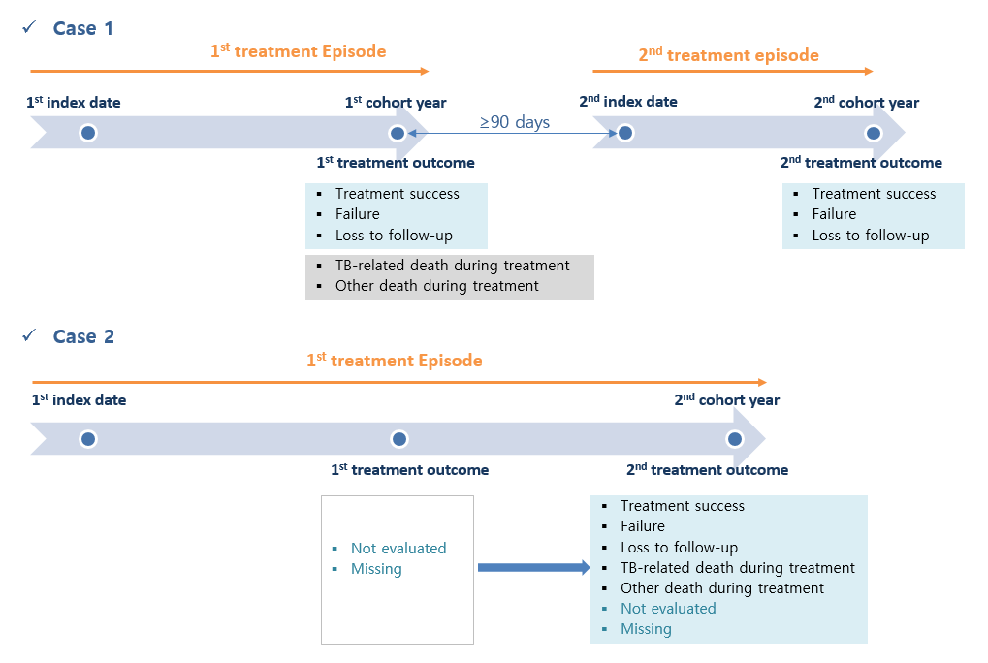
Supplemental Material 2. Criteria for treatment episode and treatment outcome in the cohort year.

