Supplementary File
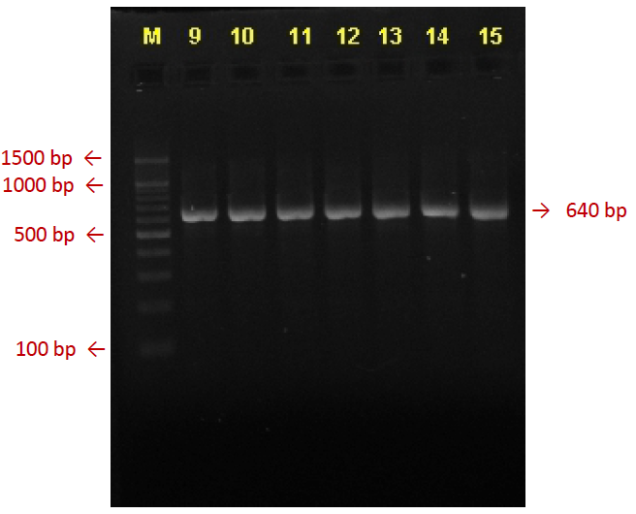
Figure S3. Visualisation of PCR product of CYP2B6 785A>G

