Supplementary File
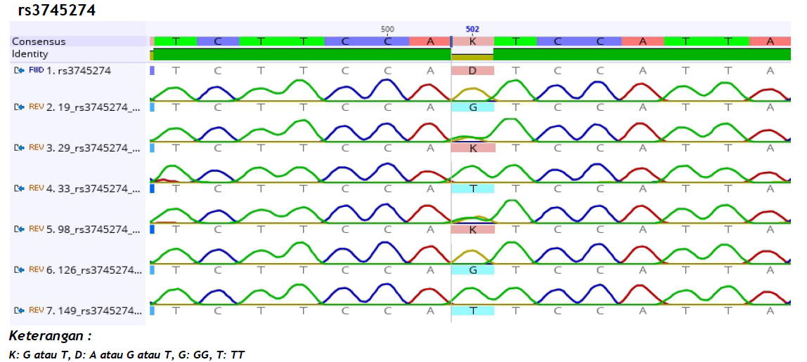
Legend: K = G or T; D = A or G or T; G = GG; T= TT

Figure S4. DNA Sequencing on CYP2B6 516G>T

