Supplementary File
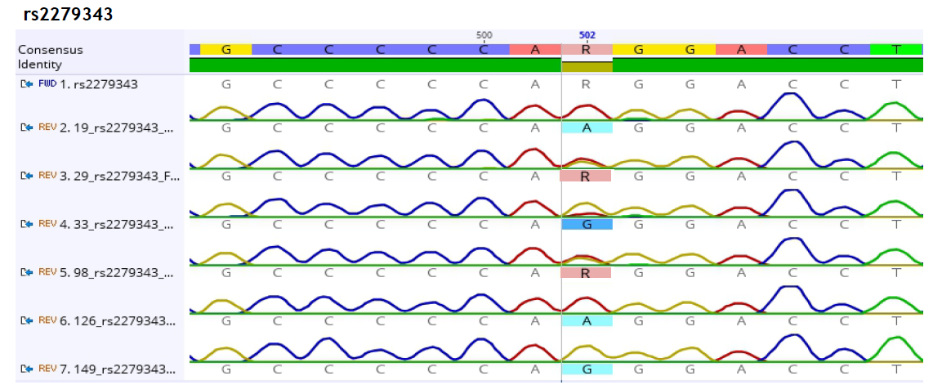
Legend: R= A or G; A= AA; G= GG

Figure S5. DNA Sequencing on CYP2B6 785A>G

