Kidney cancer
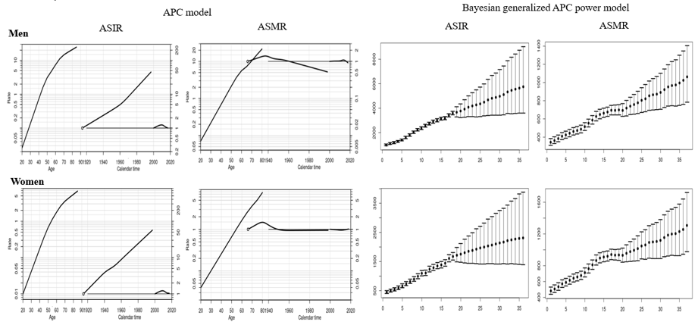
APC analysis | Terms in model | Summary statistics
 |  | Deviance (df) | △D (△ df) | Effect | p-value | Adj-$R^{2}$
Incidence
Men | Age | 2,422.61 (247) | - | - | - | -
 | Age+drift | 941.59 (246) | 1481.02 (1) | δ | A | < 0.0001 | 0.61
 | Age+period | 760.63 (243) | 1661.98 (4) | P | A | < 0.0001 | 0.68
 | Age+cohort | 871.35 (243) | 1551.25 (4) | C | A | < 0.0001 | 0.63
 | Age+period+cohort | 671.42 (240) | 199.93 (3) | P | AC | < 0.0001 | 0.71
 |  |  | 89.21 (3) | C | AP | < 0.0001
Women | Age | 1,306.82 (247) | - | - | - | -
 | Age+drift | 449.47 (246) | 857.35 (1) | δ | A | < 0.0001 | 0.65
 | Age+period | 385.52 (243) | 921.30 (4) | P | A | < 0.0001 | 0.70
 | Age+cohort | 432.83 (243) | 873.98 (4) | C | A | < 0.0001 | 0.66
 | Age+period+cohort | 369.30 (240) | 63.23 (3) | P | AC | < 0.0001 | 0.71
 |  |  | 15.92 (3) | C | AP | < 0.0001
Mortality
Men | Age | 373.64 (242) |  | - | - | -
 | Age+drift | 361.97 (241) | 11.68 (1) | δ | A | < 0.0001 | 0.03
 | Age+period | 339.39 (238) | 34.25 (4) | P | A | < 0.0001 | 0.08
 | Age+cohort | 306.93 (238) | 66.71 (4) | C | A | < 0.0001 | 0.16
 | Age+period+cohort | 289.10 (235) | 17.84 (3) | P | A, C | < 0.0001 | 0.20
 |  |  | 50.29 (3) | C | A, P | < 0.0001
Women | Age | 331.93 (242) |  | - | -
 | Age+drift | 329.39 (241) | 2.54 (1) | δ | A | < 0.0001 | 0.00
 | Age+period | 329.30 (238) | 2.63 (4) | P | A | < 0.0001 | 0.00
 | Age+cohort | 288.90 (238) | 43.03 (4) | C | A | < 0.0001 | 0.12
 | Age+period+cohort | 287.53 (235) | 1.37 (3) | P | A, C | < 0.0001 | 0.11
 |  |  | 41.77 (3) | C | A, P | < 0.0001
Abbreviation: df, degree of freedom; △D, difference of deviance; △df, difference of the degree of freedom; δ|A, δ effect adjusted by age; P|A, period effect adjusted by age; C|A, cohort effect adjusted by age; P|AC, period effect adjusted by age and cohort; C|AP, cohort effect adjusted by age and period
Supplemental Material 14. Age, cohort and period effects for the rates of kidney cancer in the age-period-cohort (APC) model (first curve, age effect; second curve, cohort effect; third curve, period effect) and the forecasts of cancer rates in the Bayesian generalized APC power model (x-axis means the calendar year, such as 0=2000, 5=2005, 10=2010, 15=2015 (the year of observation); 20=2020, 25=2025, 30=2030, 35=2035 (the predicted year); y-axis means the number of observed or estimated cancer cases; The fan shows the predictive distribution of cancer cases from the 5% to the 95% value; dot, mean predictive value) (Abbreviation: ASIR, age-standardized incidence rates; ASMR, age-standardized mortality rates).

