- Stomach cancer
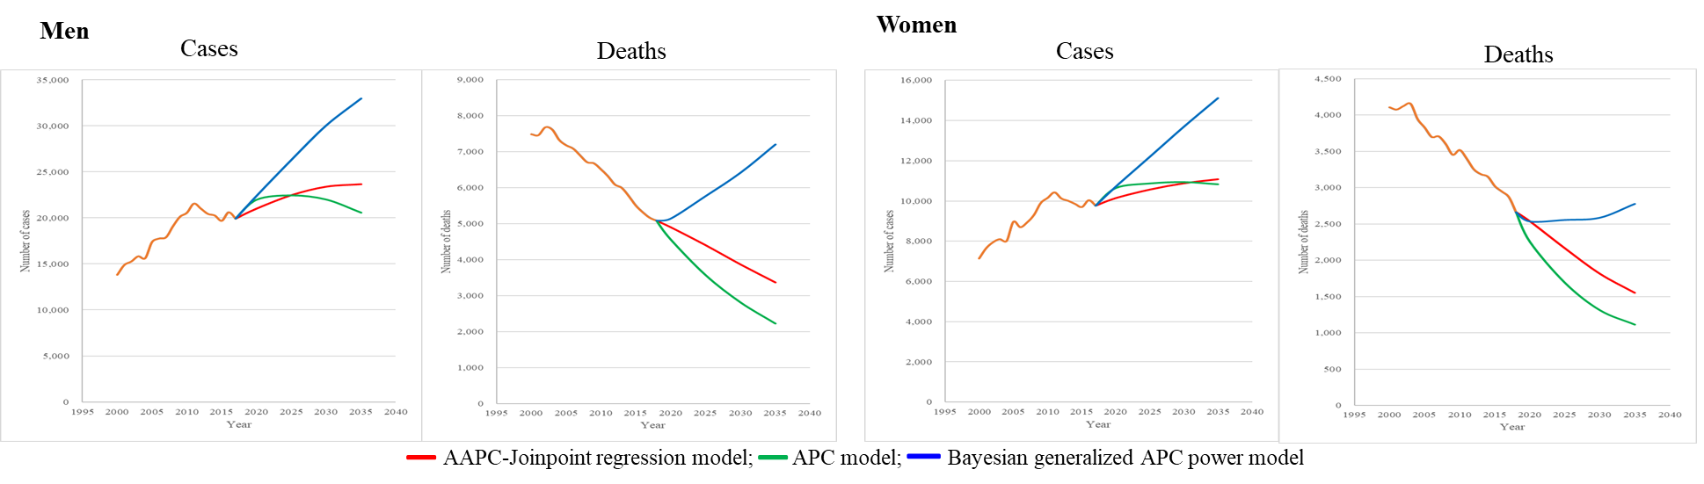
- Colorectal cancer
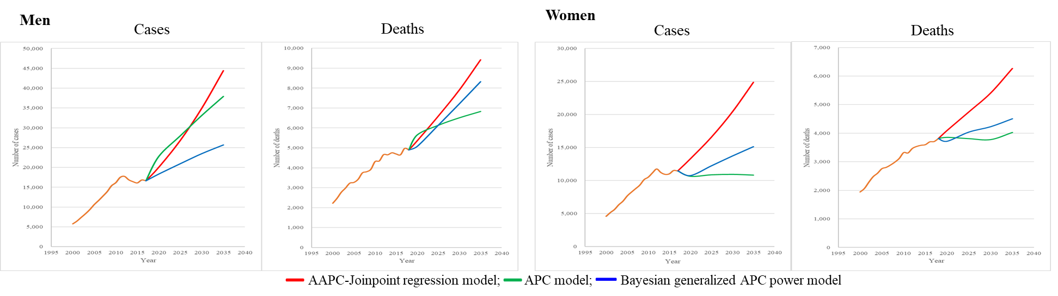
- Liver cancer
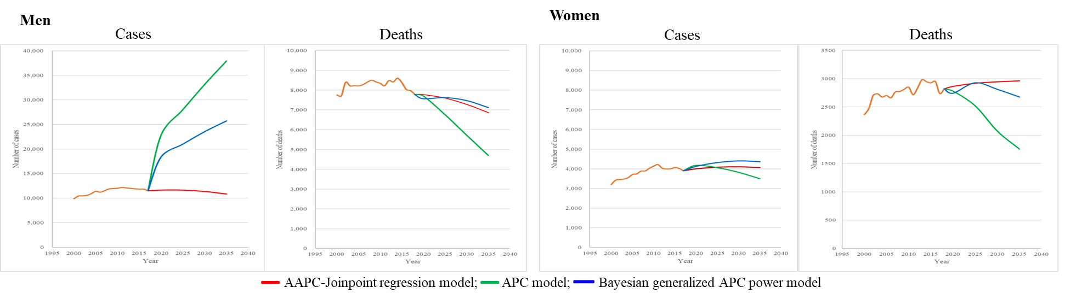

- Lung cancer
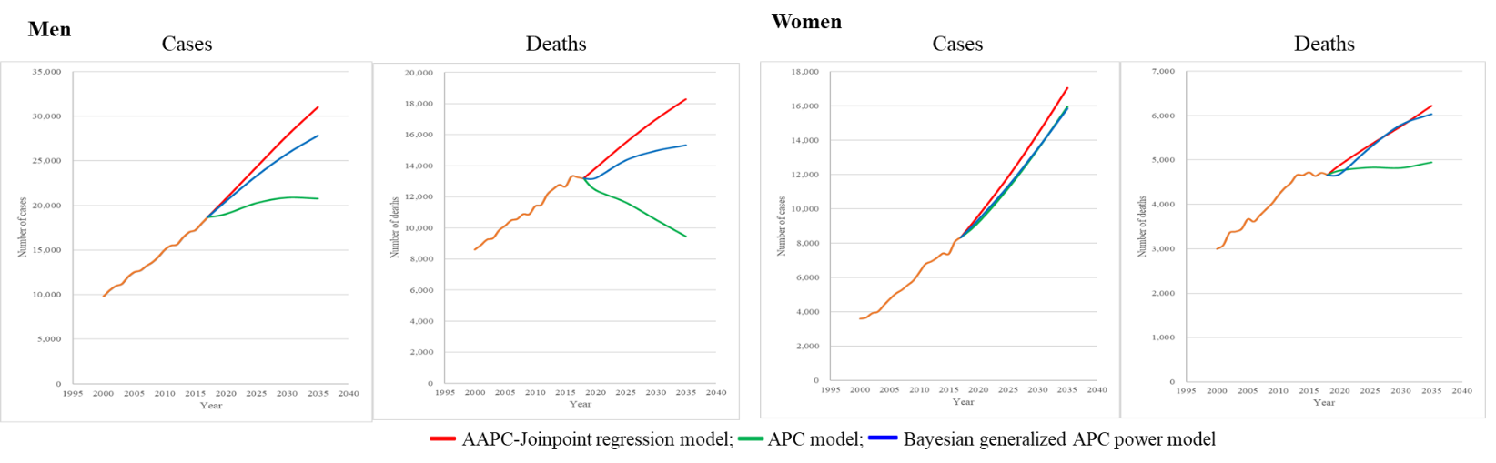
- Thyroid cancer
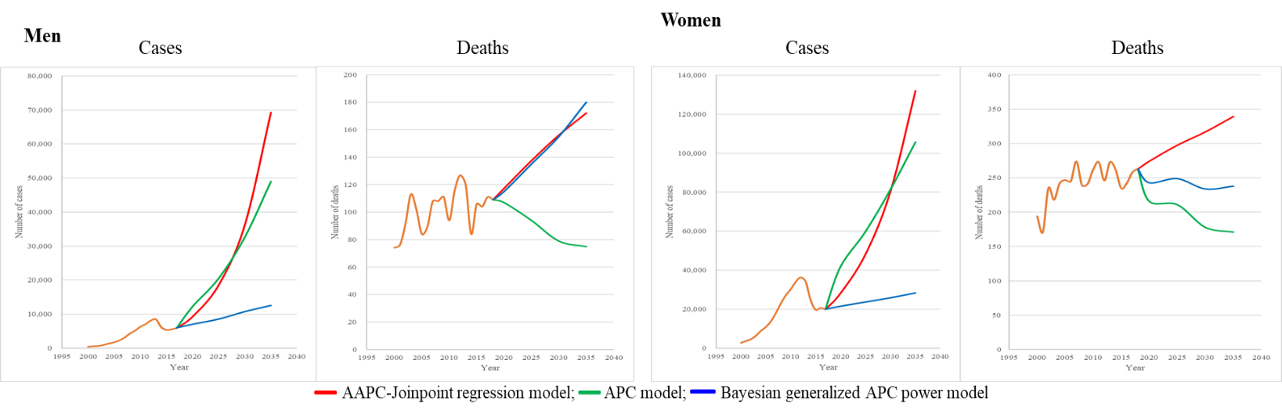
- Kidney cancer
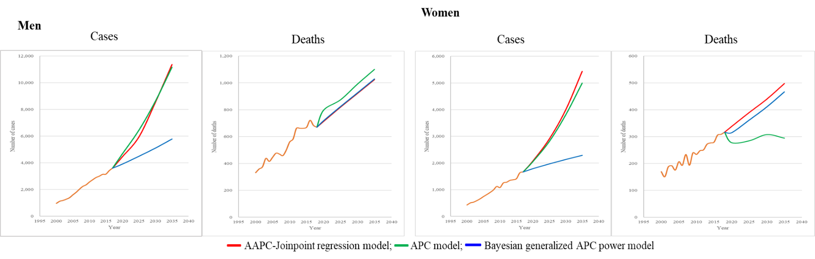

- Prostate cancer H. Female breast cancer
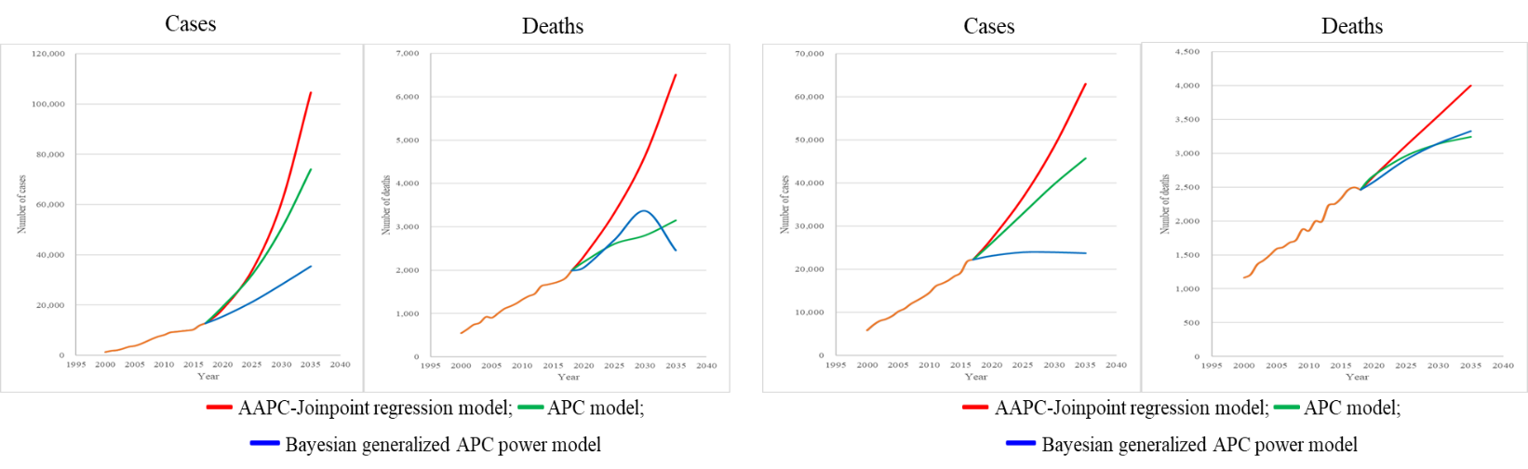
Supplemental Material 16. Comparison in the model estimates of cases and deaths from the year 2020 to the year 2035 (red line, AAPC-Joinpoint model; green line, APC model; blue line, Bayesian generalized APC power model; A. Stomach cancer; B. Colorectal cancer; C. Liver Cancer; D. Lung cancer; E. Thyroid Cancer; F. Kidney cancer; G. Prostate Cancer; H. Female breast cancer).

