- Total cancer
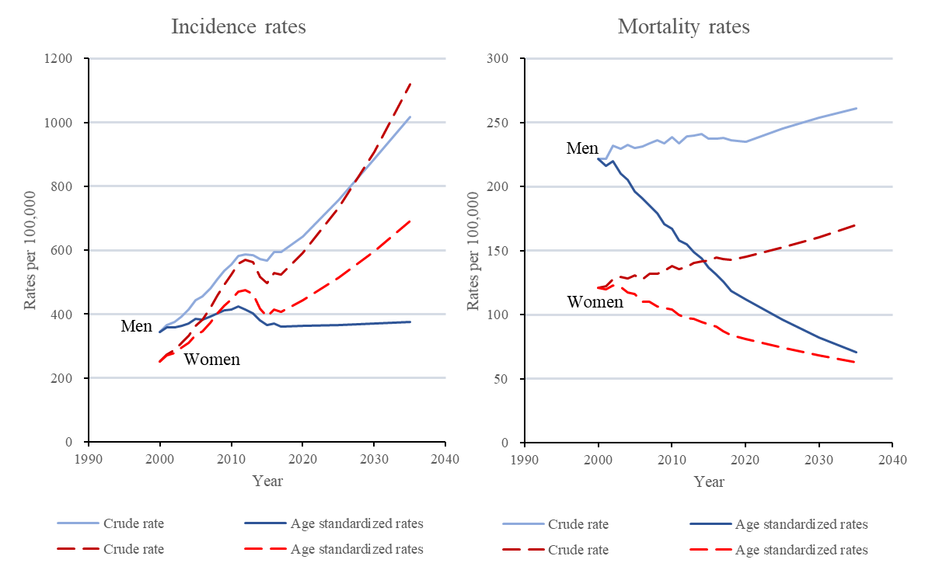
- Thyroid cancer
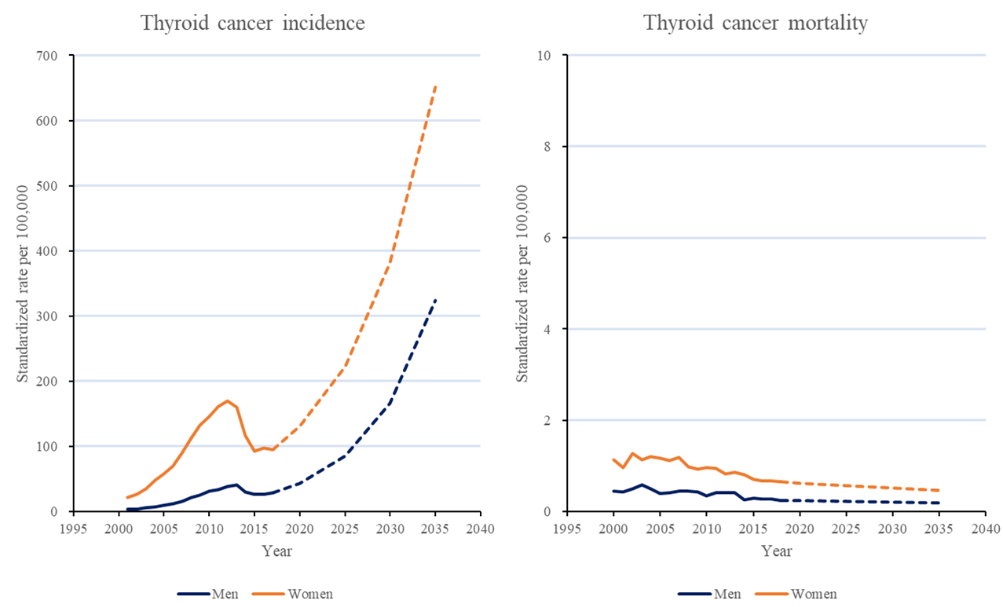
Supplemental Material 6. Model estimates for incidence and mortality rates (per 100,000 people) of total cancer and thyroid cancer among 20 years and older Korean population from the year 2000 to the year 2035 in AAPC-Joinpoint regression model (Standardized using population of the middle of the year 2000).

