A | 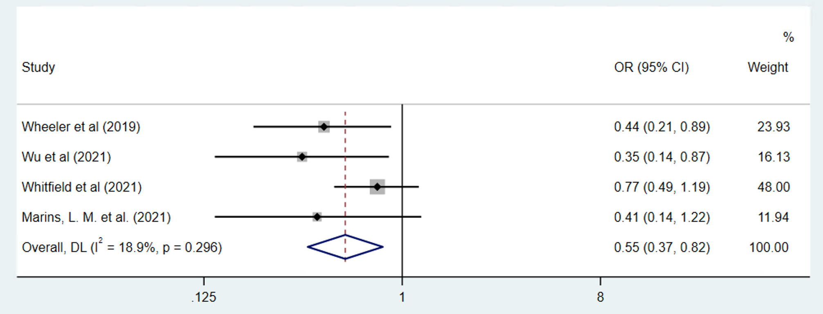
B | 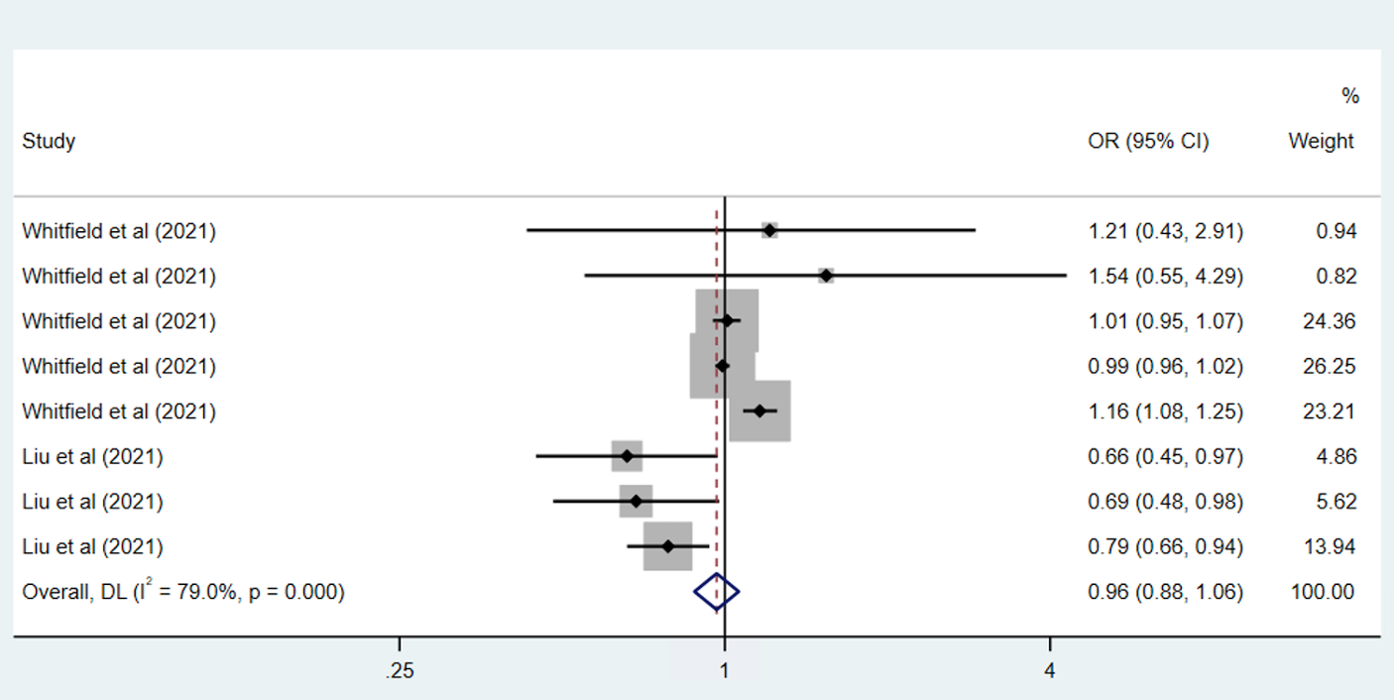

Figure S5. The pooled estimates of PrEP adherence for depression (A) and perception of HIV prevention (B). OR, odds ratio; CI, confidence interval; DL, DerSimonian and Laird.

