Supplementary Materials

Table S1. Descriptive statistics of study variables

|  |  |  |  |  |  |
| --- | --- | --- | --- | --- | --- |
|  | N | Min. | Max. | Mean | Std. Dev. |
| Suicidal ideation | 268 | 1.00 | 5.00 | 2.26 | 1.22 |
| Suicidal planning | 269 | 1.00 | 5.00 | 1.37 | 0.80 |
| Suicide attempts | 269 | 1.00 | 5.00 | 1.45 | 0.93 |
| Happiness | 266 | 1.00 | 5.00 | 3.86 | 0.75 |
| Depression | 270 | 1.00 | 5.00 | 2.64 | 0.95 |
| Hostility | 268 | 1.00 | 5.00 | 2.10 | 1.02 |
| Self-esteem | 271 | 1.00 | 5.00 | 3.54 | 0.68 |

Figure S1. Depiction of the moderating effect of M (self-esteem) by plotting the simple relationship between X (hostility) and Y (suicide attempts) for different values of M

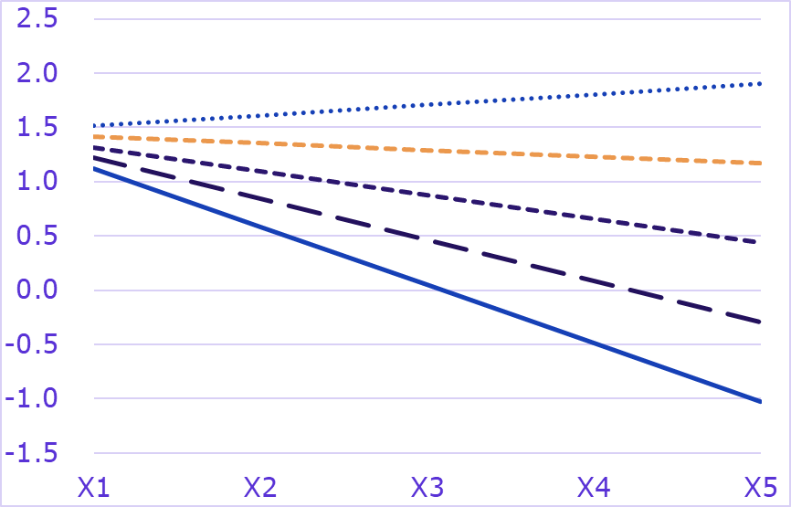

M=1

M=2

M=3

M=4

M=5

Y